SECTION JG

LUBRICATING OIL THERMOSTAT

CONTENTS

|  |  |
| --- | --- |
|  | chapter |
| Description and Operation .. | 1 |
| Servicing | 2 |
| Testing | 3 |

CHAPTER 1

DESCRIPTION AND OPERATION

1. The thermostat unit mounted on the 'B' bank side of the free-end cover, is fitted to ensure a rapid warm up of oil from cold by initially preventing flow through the oil cooler and as temperatures rise during engine running, to maintain the oil at optimum temperature by regulating flow to the oil cooler.
2. Housing (14)(Fig JG.l), fitted with thermostatic element, has one oilway connecting with outlet oilway (3) in the free-end cover (4) and a second oilway connecting with cover oilway (5) which conveys oil to the cooler.
3. Oil from the engine driven lubricating oil pumps is supplied to the thermostat unit via oilway (11). Whilst the oil is cold sliding sleeve (17) is held in contact with spindle seat (6) by the action of the springs (8) and (9), causing all oil to flow to oilway (3) through the bore of the sleeve.
4. As the oil temperature rises element (10) will expand and sleeve (17) will move towards seat (18) against the action of springs (8) and (9). At full operating temperature the sleeve will be hard against the seat allowing all oil to flow to the cooler via oilway (5). Any further expansion of the element will be absorbed by overtravel spring (13).
5. Under normal operating conditions the sleeve will be partially stroked, dividing oil flow between outlet oilway (3) and cooler oilway (5).
6. To prevent leakage between the unit oilways and to provide a guide for the sliding sleeve, 'O’ rings (15) are fitted in the bore of carrier (16) which is pressed into the body.
7. Seat (18) is secured in the housing by nut (20) and washer (21). 'O' ring (19) provides a seal between seat and housing.

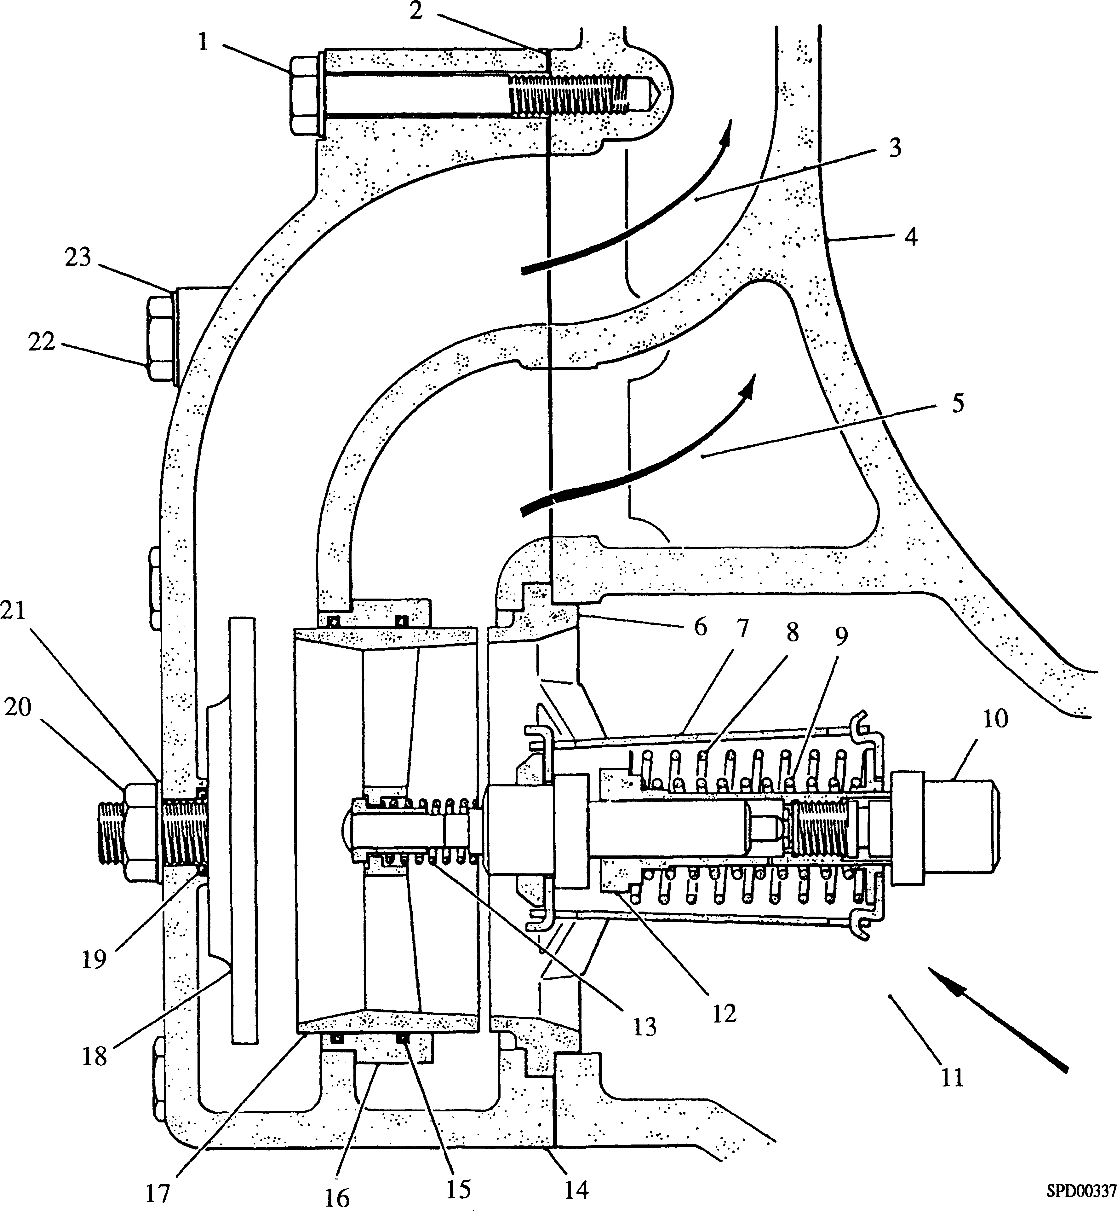

**Key To Numbers**

|  |  |  |  |
| --- | --- | --- | --- |
| 1. | Bolt | 13. | Overtravel spring |
| 2. | Joint, housing to free-end cover 14. | | Thermostat housing |
| 3. | Outlet oilway | 15. | 'O' ring |
| 4. | Free-end cover | 16. | Carrier |
| 5. | Oilway, leading to cooler | 17. | Sliding sleeve |
| 6. | Spindle seat | 18. | Seat |
| 7. | Element side strap | 19. | ’O’ ring |
| 8. | Spring, outer | 20. | Nut |
| 9. | Spring, inner | 21. | Plain washer |
| 10. | Element | 22. | Bolt |
| 11. | Inlet oilway | 23. | Plain washer |
| 12. | Spring carrier |  |  |

**Fig JG.l Lubricating Oil Thermostat (Shown partly open)**

CHAPTER 2

SERVICING

Removal

1. Release the seven M10 bolts (1) securing housing (14) to free-end cover(4) and remove housing. Discard joint (2).
2. Withdraw the element assembly from the housing. Remove carrier 'O' rings (15) and discard.
3. Do not disturb the seat assembly or the sleeve carrier unless renewal is necessary or leakage from below the seat securing nut and washer is evident.

Inspection

1. Check carrier (16) for wear or damage. Renew if necessary.
2. Examine seat (18) for pitting or corrosion. Renew if necessary.
3. Check function of element as detailed in Chapter 3.

Assembly and Fitting

NOTES 1 This procedure is based upon the assumption that the unit has been fully dismantled for component renewal.

2 All joints and 'O' rings must be fitted dry.

1. Fit a new 'O' ring (19) to the shank of the seat stud. Insert the stud through the drilling in the housing body, fit and tighten washer (21) and nut (20). Use an angled inspection mirror and light to verify that seat is fully bedded.
2. Press carrier (16) into position. Check that it is seating properly.
3. Fit new 'O’ rings (15) to the carrier.
4. Check that replacement element is of the correct rating. (The nominal temperature rating is stamped on the element side strap). Centralise 'O' rings (15), apply a film of grease around the sliding sleeve adjacent to the seating face to assist entry into the carrier 'O' rings and push the assembly into the housing. Check that spindle seat
5. is correctly located in the housing counterbore.
6. Using new joint (2), fit housing (14) in position on free-end cover (4) and secure with one bolt M10 x 50 mm long and six bolts M10 x 70 mm long and plain washers.

CHAPTER 3

TESTING

1. The operating temperature of the thermostatic element is Factory pre-set and is non-adjustable.

***NOTES***

1. The sliding sleeve (17) should start to lift off spider seat (6) at 2.8 °C(5°F) below the NOMINAL temperature rating stamped on the element side strap and should be fully lifted at 5.6°C (10°F) ABOVE the nominal rating.
2. DO NOT USE HOT OIL TO TEST THE OPERATION OF THE ELEMENT.

Prepare a container of water at a temperature which is 5.6°C (10°F) below the nominal rating of the element to be tested.

3.1

3.2

3.3

3.4

Immerse element in the water and stir vigorously with the element for 5 minutes. At the end of this period check that sliding sleeve has not lifted off the spider seat.

Raise the temperature of the water to 8.3°C (15°F) above the nominal temperature of the element.

Immerse element and stir vigorously for five minutes. The element should now be fully stroked. This may be checked by quickly inserting the element into the housing and pushing the spider seat fully into its counterbore. If the action of the over-travel spring can be felt, the element is fully stroked. This procedure must be carried out quickly before the element can change its temperature.